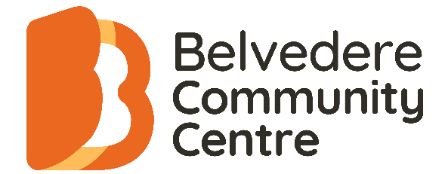
Program Guide - Term 3 2026
13th July – 18th of September
Helping to create a connected and confident community

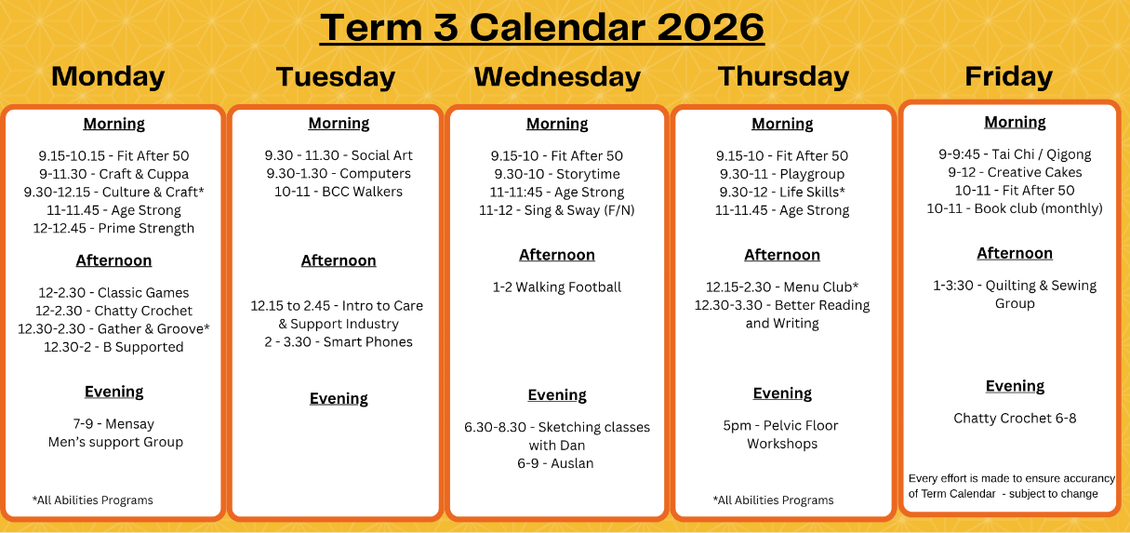

Office hours: Monday – Friday 9:00am –3.30pm
Healthy Futures Hub
151 East Road, Seaford 3198
Phone: 9776 8922
Email: reception@belvedere.org.au
www.belvedere.org.au

About Us

About us
Belvedere Community Centre Inc. (BCC) grew from humble beginnings in 1975 and moved into the Healthy Futures Hub in 2023. We provide recreational and educational programs, as well as personal and social development programs.

Program Information
Enrolments
Enrolments for classes are to be confirmed by payment in full. If you have financial difficulties, we can organise a regular payment option. Classes are subject to enrolment numbers.
To be eligible for our government subsidised training places you must be an Australian Citizen / Australian Permanent Resident or New Zealand Citizen.

Fees
MEMBERSHIP FEE: The Belvedere Community Centre Inc. is an incorporated Association. All participants involved in program/activities are required to be members of the Centre. The annual membership of $5 single / $8 family must be paid at the beginning of the New Year for renewals or at the time of enrolment.
All ACFE classes incur a $15 administration fee for 3rd party provider payments. Can be invoiced to 3rd parties in line with NDIS code of conduct and payment schedule.
Refunds
We regret that classes with low enrolments may be cancelled or deferred, and you will be advised by telephone prior to the commencement of the class.
The membership fee is not refundable.

Public Holidays
Classes will not run on Public Holidays. School holidays have special arrangements. Please ask at the office if your class is affected by School Holiday programming.

Special Needs
Arrangements will be made where possible to integrate students with special needs. Ask at the office when enrolling.

Compliments & Complaints
BCC feedback policy for compliments and complaints can be found on our web site or ask at reception.

Disclaimer: All details in this brochure were correct at the time of printing. BCC Inc. takes no responsibility for changes in details or incorrect information.

** All Abilities classes have a separate trifold brochure**
CHILDREN’S PROGRAMS

Storytime
Come and join the Frankston Library team for a fun Storytime session.
All ages welcome; the session is held in the theatre of the Healthy Futures Hub during the school term.
Wednesday FREE 9:30am – 10am

Rhythm and Rhymes Playgroup
Spend an hour and a half each week singing, playing, and connecting with other families. Because our sessions are fully facilitated and expertly planned from start to finish, we charge a small fee to cover our dedicated coordinator and program design. All you need to do is turn up and enjoy!
Wednesday and Thursday $55.00 per term 9:30am – 11am

*Playgroups are held at Davey Richardson Pavilion – 151 East Rd, Seaford
Look for our orange flag!

HEALTH AND WELLBEING CLASSES

Walking Football/Soccer
Walking Football is a low impact, modified version of soccer where players are required to walk instead of run. Reducing injury risks, making it ideal for anyone looking for a gentle yet engaging way to stay active.
Wednesday FREE 1pm – 2pm

Tai Chi & Qigong
Experience the gentle power of movement with indoor Tai Chi & Qigong sessions. Improve balance, flexibility and peace of mind.
Friday 9am - 9:45am
$7.50 a session or buy a loyalty card – 10 sessions for $60

Fit after 50
Focusing on aerobic fitness, balance, strength, and coordination in a fun environment. A combination of Tai Chi, aerobic and Yoga moves.
Mon, Wed & Thursday 9:15am – 10:15am
Friday 10am – 11am
$7.50 a session or buy a loyalty card – 10 sessions for $60

Age strong
A group fitness class, focusing on exercises that include strength training, such as chair stands, arm curls, resistance band exercises, balance exercises, single-leg lifts. Ideally to improve stability and reduce fall risk. Designed to make everyday activities easier and to help maintain independence. Will need a doctor’s letter/ referral is essential.
Monday, Wednesday & Thursday $7.50 a session 11am – 11:45am

Prime Strength
Modified pump classes for over 50's. This is a resistance workout aimed at strengthening the muscles & cardiovascular system, while increasing bone density, flexibility, strength, endurance and balance. Ideal for men & women. Using bars and weights. This class caters to all ability levels.
Monday 12pm - 12.45pm
$7.50 a session or buy a loyalty card – 10 sessions for $60

Belvedere Walkers
These medium paced walks will leave from the hub and utilise the nearby walking tracks. Prams, dog’s, carers and support worker’s welcome.
Tuesday FREE 10am – 11am

ADULT EDUCATION CLASSES

Better Reading and Writing
Improve and develop communication skills for everyday life at home or the workplace, with lessons in reading and writing. Job Active and Centrelink recognised, for skills development.
Thursday $120 for the term 12:30pm – 3:30pm

Auslan (Enquire at Reception for the level)
AUSLAN pre-accredited training introduces you to the foundations of AUSLAN and Deaf culture in a welcoming, supportive environment. You’ll learn practical signs and communication skills that can be used in everyday life, work, and community settings.
Wednesday $165 (Includes a printed workbook) 6pm – 9:00pm

Introduction to the care and support industry
Thinking about a new job where you can help others? Join our short course, friendly introduction to the care and support industry, with a focus on disability. This relaxed course is perfect for beginners. You will learn the basics of looking after people in your community. It is a great way to try something new, build your confidence, and see if you like the work before doing more study, volunteering or applying for jobs.
No experience is needed to join!
Starting 11th of August – 20th October
Tuesday $50 (Introductory offer) 12:15pm-2:45pm

COMPUTER CLASSES

Computer Skills
This course will help you improve your skills and knowledge. Designed for computer literate beginners.
Tuesday $120 for the term 9:30am – 1:30pm

Smart Phone – Unlocking the potential
We’ll help you navigate your Apple or Android device with confidence:
- Staying connected: Mastering calls, texts, and video calls.
- Exploring apps: Discovering useful apps like social media, weather, and news.
- Security basics: Simple steps to keep your information safe.
Starting 14th July – 4th August
Tuesday $50 (4-week short course) 2:00pm - 3:30pm

Digital support - B Supported
One-on-one technical support for your phone, tablet or laptop. We can help with setting up a device, organising photos, uploading, downloading, attaching a PDF or other digital assistance.
Book a 20-minute session with Emma.
Monday FREE 12:30pm – 2pm

SOCIAL PROGRAMS

Junk Journaling
Enjoy creating a journal or simple collages of memories from magazines, newspapers, collections from home etc. Supportive wellbeing environment with plenty of ideas and prompts as well as freedom to do your own projects.
Wednesday FREE (EOI Only) 1:45pm – 2:45pm

Fortnightly Garden Community Meet-Up
Do you enjoy gardening? Come and join us for a relaxed meet-up at the Healthy Futures Hub community garden. This is a space to connect with others who enjoy gardening, whether you’re experienced or just starting out. We’ll be sharing our own gardening journeys, the successes, the challenges, and the lessons along the way. A chance to learn from each other, offer ideas, and enjoy good conversation. Feel free to bring along a plant, cutting, or seeds to share if you’d like.
Fortnightly Thursday FREE 10:30am – 11:30am

Chatty Crochet
Whether you’re a total beginner or a seasoned pro, come along for a relaxed and friendly afternoon. Facilitated by the lovely Cindy, this program is all about enjoying a cuppa, sharing a laugh, and working on your latest project in a supportive, stress-free environment.
Monday $5 per session 12pm – 2pm
Friday Evenings $5 per session 6pm – 8pm

Book Club
Join the Belvedere book club. They meet once a month to explore a diverse range of books and share thoughtful conversations.
Last Friday of the month $5 per session 10am – 11:30am

Social Art Classes
Join with like-minded creatives to work on your drawing, painting, pastel and other mediums. Sharing knowledge together.
Tuesday $5 per class (BYO your own materials) 9:30am– 11:30am

Craft N Cuppa
BYO craft. Set time aside to finish projects or start new ones while sharing your skills and friendship, for example: knitting, card making, diamond art, crochet.
Monday $5 per session 9am – 11:30am

Classic Games
Use our board games and cards or bring your own to make up a table and have some fun. Games such as Rummy-O, chess, cards etc
Monday $5 per session 12pm – 2:30pm

Creative Cakes – A new timetable of themes each term!
Learn how to make stunning decorated cakes and develop skills such as piping, sugar flowers, cake decorating, figurines and more. Beginners welcome! Bookings are essential.
Friday $35.00 per session 9am – 12pm

Quilting & Sewing Group
Come and join a likeminded group of quilters, sewers, and patch workers. Work on your own project in the company of fellow sewers! Share your knowledge and learn from others. Beginners welcome.
Friday $5 per session 1pm – 3:30pm

MenSay Men’s support group
The group meets every Monday night during the school term for a chat, cuppa and to offer social support to each other. The group meets at 7pm (after office hours), offering a safe and confidential space to share each other’s experiences in a casual and non-confronting way, which creates a culture of respect and trust.
Monday $5 per session 7pm – 9pm

Sing & Sway
Love music? Come join Sing & Sway. A fortnightly singing group where we sing and gently sway along to uplifting tunes with written lyrics and music. Led by Sarah, no experience is needed, just a love for singing and good company. Come for the music, stay for the joy!
Wednesday (fortnightly)
Dates: 15th & 29th July 12th & 26th August 9th & 16th September
$5 per session 11am – 12pm

WORK SHOPS

Pelvic Floor Exercise program 4 – week
Wednesdays - June 17th, 24^{th &} July 1st & 8th $60 5:00pm – 6:15pm
Evening Sketching with Dan
This 4-week short course will take participants through the foundations of sketching in a warm & friendly environment. Dan Lynch is a much-loved local artist with success in Art Exhibitions & Community Events.
Wednesday Evenings $120.00 6:30pm – 8:30pm
Starting 15th July – 5th August

Participants are encouraged to bring their own sketching journal



Web: www.belvedere.org.au

